**PRACTICAL NO.9**

**9. Write a program to understand the use of Firebasae with Raspberry Pie to control sensors.**

**Raspberry-PI_DHT11_Firebase:-**

In this project I am going to post the real time data of temperature and humidity sensor to the Firebase database. I am using DHT11 Sensor to communicate with raspberry pi.

**Important Features:-**

* The Firebase Realtime Database is a cloud-hosted database.
* Single client sensor data is Collaborate with cross-platform apps like IOS, Android, and JavaScript SDKs as well as many IoT hardware with ease.
* Data of sensor stores with specified key-value pairs to change the behavior and appearance of your app without requiring any download an update.

**Devices Used in project:-**

Raspberry Pi 3 Model B

DHT11 Sensor

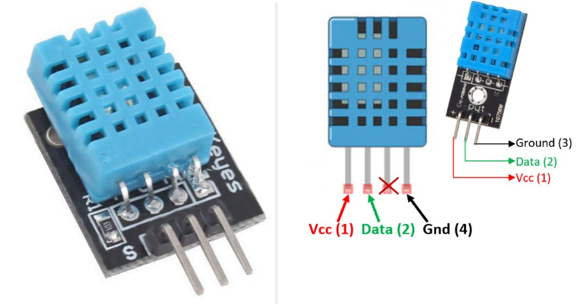

Connector Cables

#We are using Python code to send the real time data of DHT11(temperature and humidity sensor) to Firebase

import Adafruit_DHT as DHT

from time import sleep

from firebase import firebase

#API KEY

firebase = firebase.FirebaseApplication('https://rpitempdata.firebaseio.com', None)

while True:

humid, temp = DHT.read_retry(DHT.DHT11, 4)

print("Let's start with getting python to read from the sensor..")

print("humidity is", humid)

print("temperature is", temp)

print("Now let's upload that to Firebase")

#Patches on extra data from our temp and humidity variables at the top of the program,

simulated sensor readings

result = firebase.patch('/sensor/dht/', {'Temperature': temp, 'Humidity': humid})

sleep(2)

print("Give it a moment to upload...")

sleep(2)

print("Okay Done")

print("Now seeing if we can read from the database...")

print("The last uploaded temperature was:")

result = firebase.get('/sensor/dht/Temperature', None)

print(result)

print("The last uploaded humidity was:")

result = firebase.get('/sensor/dht/Humidity', None)

print(result)

sleep(3)

print("program done")

sleep(1000)

**Output:-**

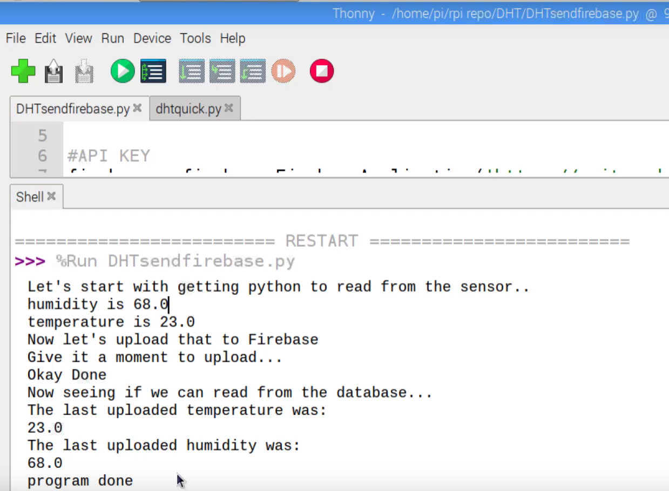

**Firebase:-**

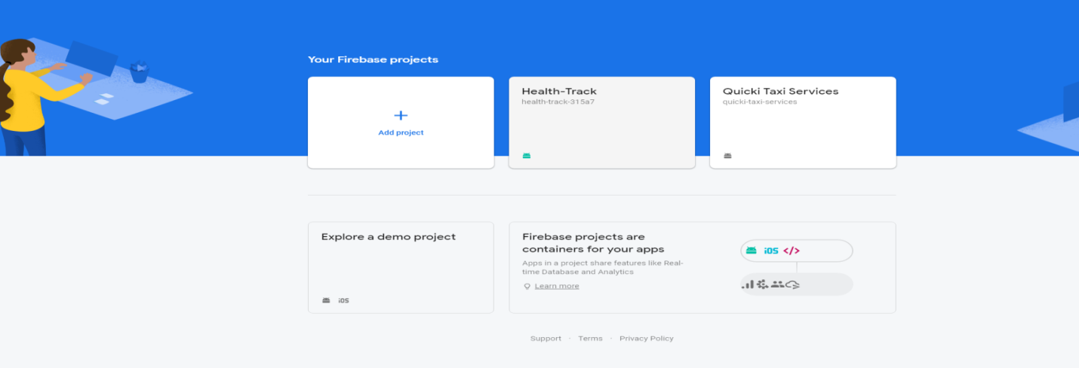

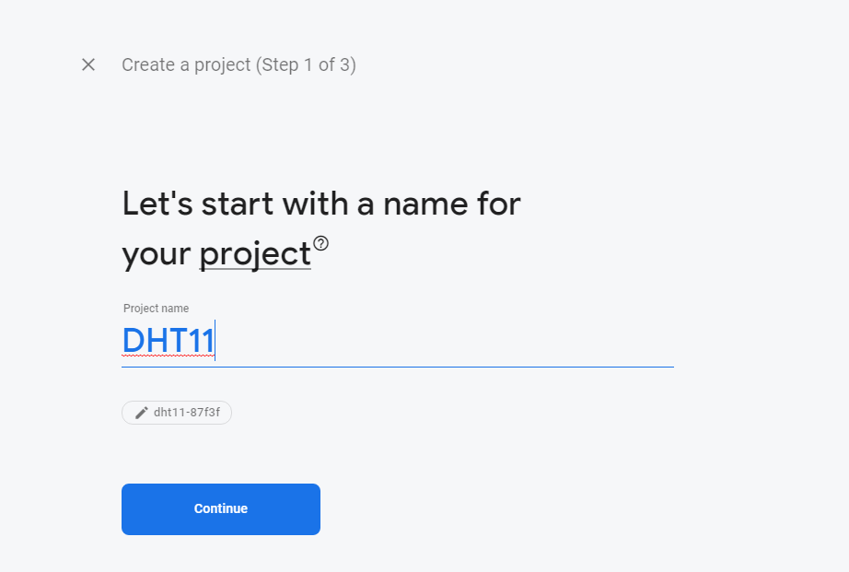

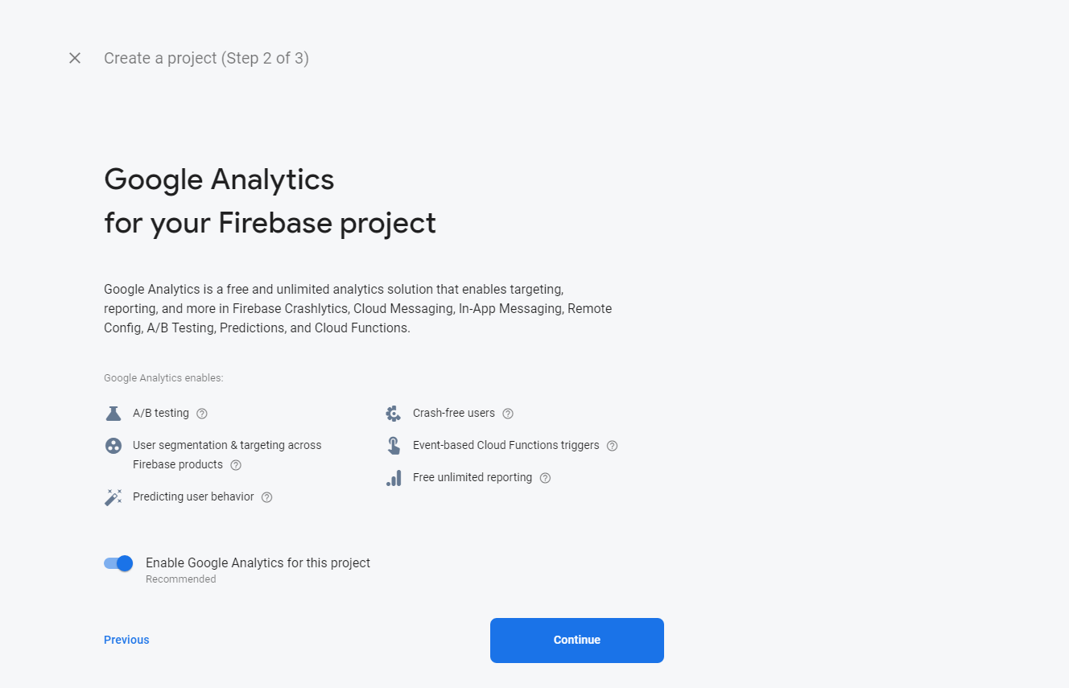

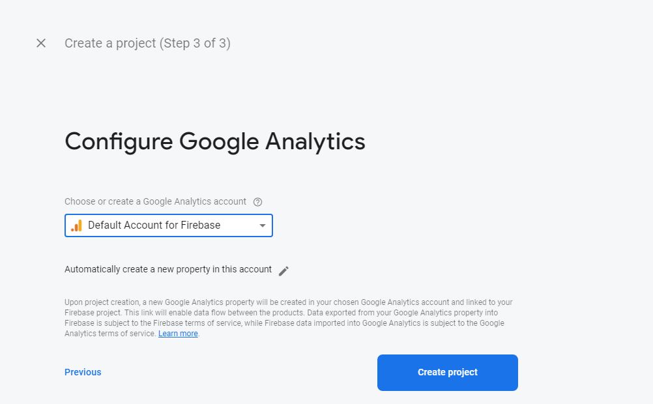



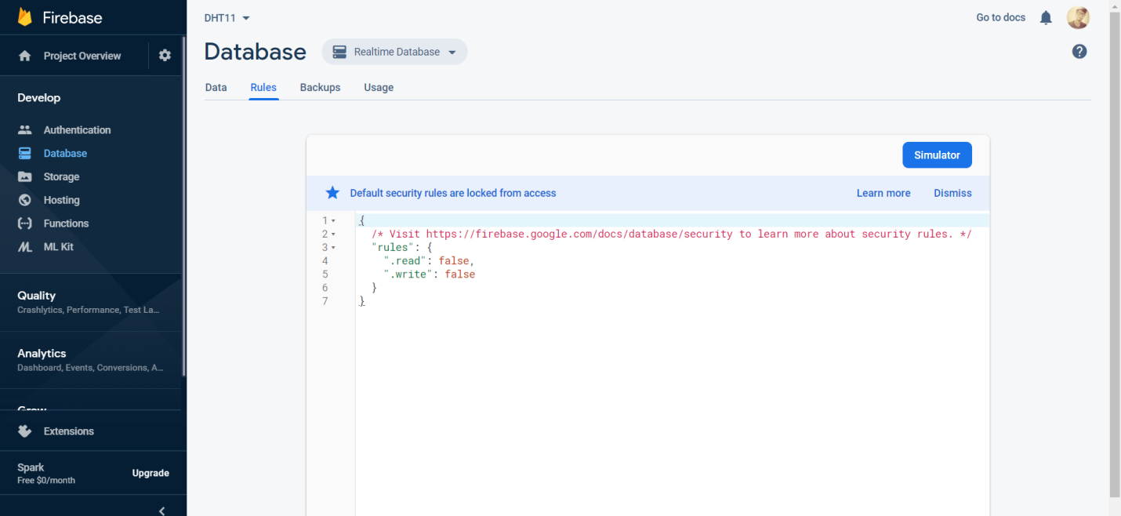

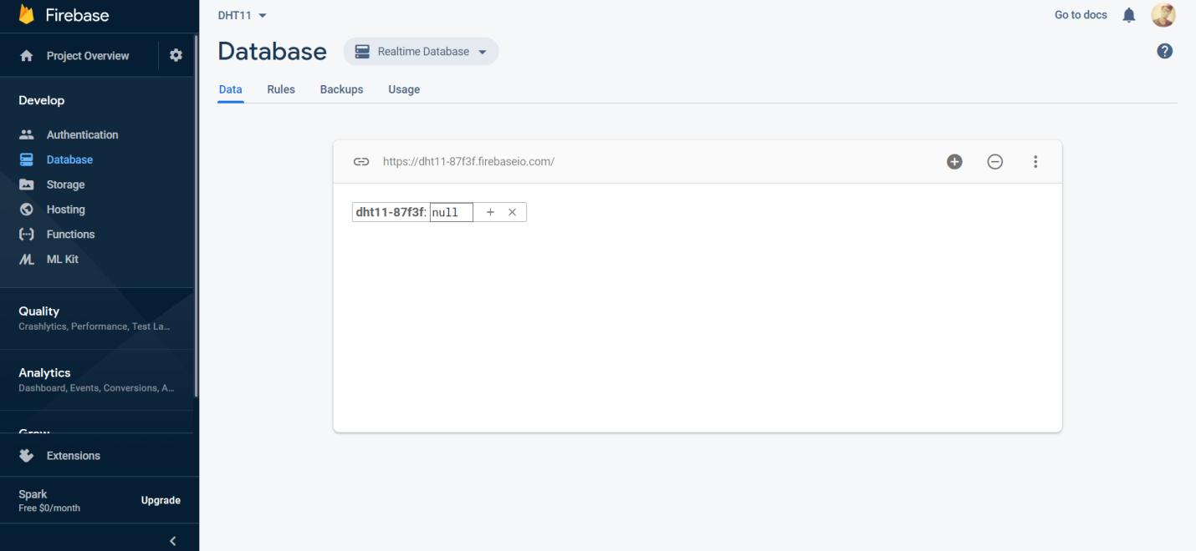

Your Realtime Database is ready to use.  
and show URL Link for your firebase realtime database.

Now Make Raspberry Pi sent data to Firebase Realtime Database